D

DATABASE BOOTCAMP

There seems to be a good deal of debate about the language most suitable for learning on computers and one rarely offered is SQL – ‘Structured Query Language’. It is the international standard use to control databases and I contend easier to learn than most code. It is what is known as a ‘high level language’ i.e. very close to a clipped form of English and has applications that cover a huge range of applications not least that of manipulating intelligent websites!

Once you start to play you will understand the rhythm, or the syntax, in speaking SQL to the point where you could almost guess a command.

Follow this sequence on your own Pi and I explain how to get MySQL working and produce a solid platform on which you can develop your database skills – beyond the scope of this article.

Installing MySQL  We are going to use an Open Source version of SQL called ‘MySQL’ but this is not included in the standard Raspbian Distribution so needs to be located downloaded and installed onto your Pi. Luckily, this complex process is controlled by one command and is run in a text screen or window.  Your Pi trundles off and begins the download. There may be periods in this process where nothing appears to happen but be patient. Eventually you will be presented with a blue screen and asked to set a password for MySQL – twice for confirmation.  Databases  A table has columns and rows – in database speak these are called fields and records. A large database can contain many tables – and so it goes.  There are three basic functions in maintaining any data in a table:- add, delete and modify.  So in terms of the data we keep we can add a new record, delete and old record or modify the contents of an existing record – that is all! (DML).  It terms of how we keep the data we can add, delete and modify tables and add. delete and modify fields – that is all! Master these commands and we are well on our way to controlling databases. (DDL).  Once the data is in place it is useless unless we DO something with it and this too can be reduced to two basic functions sort and search. | Data  We have managed to reduce elementary databases down into a few functions but before we proceed into MySQL we need to take one final look at data itself.  If ever you have needed to complete a form, paper based or on a web site you would have come across one where the requirements are unclear or your response would not fit into the space available. You can scribble notes on a paper form or reduce the size of your handwriting to fit but that’s not possible on computers they are more highly defined. So it is with ‘data-types’. MySQL recognizes only three types of data text, number and date. To store the data efficiently it needs to allocate the correct amount of computer storage space too.  Entering MySQL  Enter MySQL using the command mysql –u root –p. From here on you have left Raspbian and now need to type SQL Structured Query Language. Although SQL is an international standard local variations exist and MySQL is a particularly polite version. You have to say please at the end of every command otherwise nothing happens.  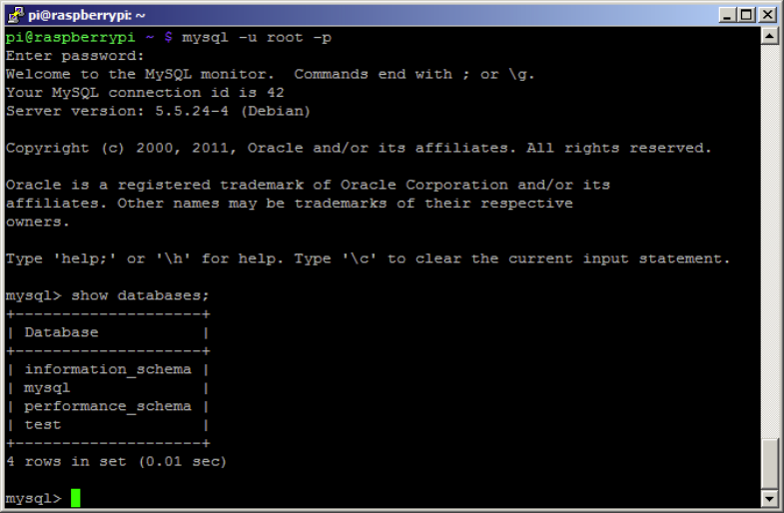  The short cut for please is the semi-colon. No ; no action.  Viewing the databases  To show the existing databases simply type:  Should you forget your manners enter the please ; on a separate line. You will display the four default databases. Before we start changing things lets become confident in our ability to look around. e.g
  pr0mpt > apt-get install mysql-server
  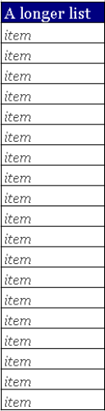 | 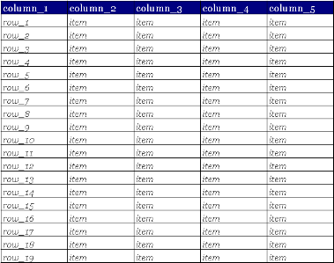  The very simplest database is a list. A list become more useful the longer it gets but probably then requires more columns so you end up with a table.
  pr0mpt > show databases;
  pr0mpt > show tables in information_schema;

….  This displays the list of tables in the database information_schema. The columns in a table can be seen in three ways. All produce the same result:-  Note the general format of the command describes the table in the database separated by a full stop i.e.  pr0mpt> show fields in <databasename>.<tablename>  Work through and try these examples and test your own options to gain the most from this article. A typical output is:-  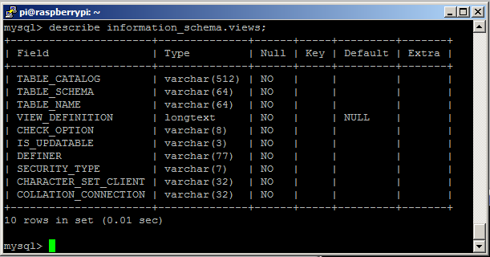  Here you can see the columns – called fields other details that will be explained shortly.  Viewing the data  We can go further by selecting to see all the data in any of the tables. The star * is known as a ‘wild card’ and means ‘everything’ so to select everything in a table enter:-  This is produces one extreme of output – i.e. nothing an ‘Empty set’. Notice also the timing here the Pi has taken four one hundredth of a second to produce this output.  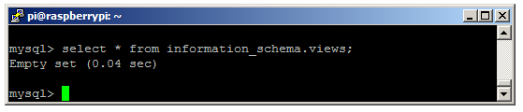  The other option is represented by:-  This produces what appears to be a mess and it is but  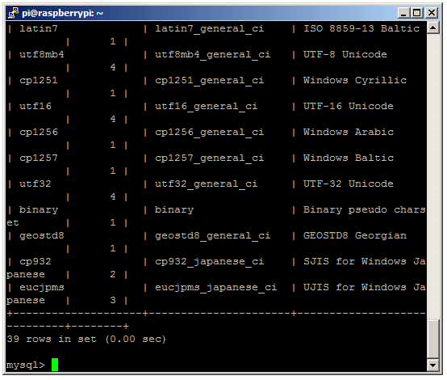 | it should look like this. All the | + and – characters are actually border lines in a crude table that looks like this:-  +---------+---------+---------+----------+-------+--------+  | col_1 | col_2 | col_3 | col_4 | col_5 | col_6 |  +---------+---------+---------+----------+-------+--------+  | data | data | data | data | data | data |  | data | data | data | data | data | data |  +---------+---------+---------+----------+-------+--------+.  Creating a Database  Now the hard bit. MySQL can become very complex. Let’s create a database called magpi type:  Prove the database has been created:-  You now want to tell the system to use your new magpi database so type:-  Creating a Table  A database can contain many tables as we have seen. Tables only need to be set up once but need to specify the data-type and size of the data it is expected to hold.  A generic command looks like this:-  A more useful example:-  Use describe birdtable; to reveal the by now familiar description:-  +------------+-------------+------+-----+-------------------+----------------+  | Field | Type | Null | Key | Default | Extra |  +------------+-------------+------+-----+-------------------+----------------+  | id | int(11) | NO | PRI | NULL | auto_increment |  | first_name | varchar(25) | YES | | NULL | |  | town | char(30) | YES | | Cardiff | |  | dob | date | YES | | NULL | |  | birds | int | YES | | NULL | |  | record | timestamp | NO | | CURRENT_TIMESTAMP | |  +------------+-------------+------+-----+-------------------+----------------+  6 rows in set (0.01 sec)  It is easier to explain this table in conjunction with the next command. This shows you how to insert data. :-
  pr0mpt > show columns in information_schema.views; pr0mpt > show fields in information_schema.views; pr0mpt > describe information_schema.views;
  pr0mpt > select * from information_schema.views;
  pr0mpt > select * from information_schema.CHARACTER_SETS;
  pr0mpt > create database magpi;
  pr0mpt > show databases;
  pr0mpt > use magpi;
  pr0mpt > create table <tablename>
  (
  <col1><col1_data-type>,
  <col2><col2_data-type>,
  <col3><col3_data-type>,
  ………,
  );
  pr0mpt > create table birdtable
  (
  id int NOT NULL AUTO_INCREMENT,
  first_name char(25),
  town char(30) default “Cardiff”,
  dob date,
  birds int,
  record timestamp default now(),
  primary key (id)
  );
  pr0mpt > insert into birdtable
  (
  first_name,town,dob,birds) values
  (
  “Fred”,”Epping”,19571225,3
  ));
  Query OK, 1 row affected (2.53 sec)
-
So let’s now examine these two commands. The INSET INTO command can be entered on a single line but it has been laid out here for clarity.It should be clearer to see that the table called ‘birdtable’ now has a row (or records) containing:-  “Fred” in first_name.  “Epping” in town  19571016 in dob (date of birth)  ie 16th October 1957 and  3 goes into birds.  Note the way data is entered. Text is surrounded by quotation marks, date is entered in the yyyymmdd format and numbers (integers) are just entered directly as numbers. Each value is separated by commas. This is what the table was programmed to accept in the CREATE TABLE command.  Try adding a few more lines of data of your own.  Top-tip: It is quicker to press the up arrow key, to recall and edit the previous line and press enter again. This save typing the whole line particularly as the rest of the command remains unchanged.  Also note that MySQL confirmations each entry with a line about the number of rows affected.  Confirm your table is being built by entering  Two useful database functions are sorting and searching. Let’s try some examples.  Viewing the data – sorting  Try sorting by entering:-  To see everything sorted by first name and  To sort the same list but this time by the descending number of birds.  Viewing the data - searching  * was introduced as a ‘wild card’ meaning anything or everything there are two others wild cards. These are % (percent) and _ (underscore). Where * meant any or all % means part and _ means one element. Try them out by entering  To see everything where the whole name is Fred and | To catch every option (if they existed) Frad, Frbd, Frcd, Frdd, Fred, Frfd …… Frzd etc … and  With any name with an r in it. Also  With any name with a letter r in it. Also  Logical  Two ‘logical’ words that can be included in SQL statements are AND and OR. AND meaning both conditions need to qualify OR means either condition needs to apply. Try commands like:-  To find names with r in AND birds greater than 3.  to find Freds OR entries with birds less than 3.  More selective  In every example above we have printed out all of the fields for each selected record. We can be more selective by typing:-  Notice here how the order by option can be added to build even bigger SQL commands.  Conclusion  There is a lot to be gained by testing these commands on your Pi. Working in text mode is a rapid way of learning, testing, building and repairing databases as well as being a fundamental computing skill.  Homework  Two fields that were included here but not discussed were ‘id’ and ‘record’.  Record automatically entered a timestamp when a new record was entered. Id was used as a ‘key’ field automatically entering a unique number for every new line.  It is these field and a method of linking databases to a web site that will be covered in future articles.
  Column | Content | Data-type
  id | integer | int
  first_name | text (max 25 chars) | char
  town | Text (max 30 chars) | char
  dob | date | date
  birds | integer | int
  pr0mpt> select * from birdtable;
  pr0mpt> select * from birdtable order by first_name;
  pr0mpt> select * from birdtable
  order by birds desc;
  pr0mpt> select * from birdtable
  where (first_name = ”Fred”);
  pr0mpt > select * from birdtable
  where (first_name like ”Fr%”);
  pr0mpt> select * from birdtable
  where (first_name like ”Fr_d”);
  pr0mpt> select * from birdtable
  where (first_name like ”%r%”);
  pr0mpt> select * from birdtable
  where (birds > 3);
  pr0mpt> select * from birdtable
  where (first_name like ”%r%”)
  and bird > 3;
  pr0mpt> select * from birdtable
  where (first_name = “fred”)
  or bird > 3;
  pr0mpt> select town, dob from birdtable
  where (first_name like ”%r%”)
  and bird > 3 order by birds;

